**QA Engineer**

**EPAM**

**A Training Report**

Submitted in partial fulfilment of the requirements for the award of degree of

**Bachelor of Technology Computer Science and Engineering**

**LOVELY PROFESSIONAL UNIVERSITY PHAGWARA, PUNJAB**

|  |
| --- |
|  |
|  |  |

SUBMITTED BY

Team: Rahul (11901965),Pradeep(11914539),Anil(11919112)

**ABOUT EPAM**

EPAM India is a subsidiary of EPAM Systems, a global provider of software engineering and IT consulting services. EPAM India was established in 2004 in Hyderabad and has since grown to become one of the company's largest and most strategic locations, serving clients across India, Asia-Pacific, and the rest of the world.

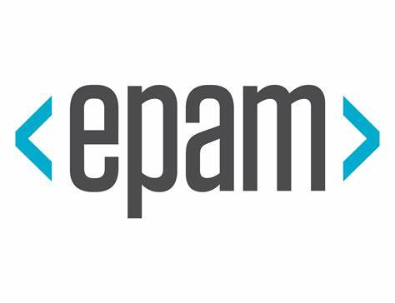

EPAM India provides a range of software engineering and IT consulting services, including software development, testing, maintenance, and support. The company serves clients in a wide range of industries, including financial services, healthcare, technology, travel, and more. EPAM India has a team of over 12,000 professionals spread across multiple locations in India, including Hyderabad, Bangalore, Pune, and Chennai.

EPAM India has a strong reputation in the Indian software engineering market, with a focus on quality, innovation, and customer-centricity. The company's team of professionals includes some of the best software engineers and IT consultants in India, who are committed to delivering high-quality solutions to clients around the world.

One of the key strengths of EPAM India is its ability to leverage local talent and expertise to deliver customized solutions that meet the unique needs of its clients. India is home to some of the world's best software engineering talent, and EPAM India has been able to attract and retain top talent from across the country. This has enabled the company to build a strong culture of innovation and excellence, which is reflected in the quality of its work and its long-term client relationships.

EPAM India is also committed to giving back to the local community and has launched several initiatives aimed at promoting education and skills development in the country. The company has partnered with local universities and schools to provide training and mentoring to students, helping to build the next generation of software engineering talent in India. EPAM India has also launched several employee-led CSR initiatives, focused on healthcare, education, and the environment.

In addition to its focus on delivering high-quality solutions and giving back to the community, EPAM India is also committed to building a diverse and inclusive workplace. The company has launched several initiatives aimed at promoting diversity and inclusion, including employee resource groups focused on women, LGBTQ+ individuals, and people with disabilities. EPAM India has also been recognized for its commitment to diversity and inclusion, winning several awards and accolades in this area.

Overall, EPAM India is a key strategic location for EPAM Systems, providing high-quality software engineering and IT consulting services to clients around the world. With its focus on quality, innovation, and customer-centricity, as well as its commitment to giving back to the local community and promoting diversity and inclusion, EPAM India is well-positioned to continue its growth and success in the years ahead.

EPAM Systems is a global software engineering services company that was founded in 1993 in Belarus. The company started as a small team of software developers in Minsk, the capital of Belarus, and has since grown into a multinational corporation with over 41,000 employees across 35 countries.

In the year 2000, EPAM was still a relatively small company with around 250 employees. However, even at this early stage, the company had already established itself as a leading provider of software engineering services. In the early 2000s, EPAM began to expand its operations beyond Belarus and into other countries in Eastern Europe, including Russia and Ukraine.

At the time, EPAM was primarily focused on providing software development services for clients in the United States and Western Europe. The company had developed a reputation for delivering high-quality software solutions on time and within budget, which helped it to win contracts with a number of large multinational corporations.

One of the key factors driving EPAM's success in the early 2000s was its focus on developing deep expertise in specific technology domains. Rather than trying to be a jack-of-all-trades, the company chose to focus on a few key areas where it could differentiate itself from its competitors.

For example, EPAM became an early adopter of Java and quickly developed a reputation as a leading provider of Java development services. The company also invested heavily in building expertise in other emerging technologies, such as .NET, mobile development, and cloud computing.

EPAM's focus on technology expertise helped it to win contracts with clients in a range of industries, including finance, healthcare, and retail. Some of the company's early clients included Citigroup, UBS, and Panasonic.

In addition to its technology expertise, EPAM also had a strong focus on process and methodology. The company was an early adopter of Agile methodologies and had developed its own proprietary Agile framework, which it called eXtensible Agile Process (XAP).

XAP was designed to provide a flexible and customizable framework for software development projects of all sizes. The framework emphasized collaboration, communication, and continuous improvement, and was designed to help teams deliver high-quality software solutions on time and within budget.

EPAM's focus on technology expertise and process excellence helped it to grow rapidly in the early 2000s. By 2005, the company had more than 1,000 employees and was generating more than $50 million in annual revenue.

In the years that followed, EPAM continued to expand its operations and grow its client base. The company opened new offices in a number of countries, including the United States, Canada, and China, and continued to develop its expertise in emerging technologies.

Today, EPAM is a global leader in software engineering services, with over 41,000 employees and more than $3 billion in annual revenue. The company continues to focus on developing deep expertise in specific technology domains and delivering high-quality software solutions to clients around the world.  
  
In 1998, EPAM opened its first office outside of Belarus, in Princeton, New Jersey. This was a strategic move to establish a presence in the United States and to be closer to its clients. Over the next few years, EPAM continued to expand its operations, opening offices in Hungary, Russia, Ukraine, and India.

In 2004, EPAM Systems became the first software development company from Belarus to be listed on the NASDAQ stock exchange. This was a significant achievement for the company and helped to raise its profile in the international business community.

Over the next few years, EPAM continued to grow, expanding its services to include product development, testing, and maintenance. The company also began to focus on specific industries, including banking, insurance, healthcare, and retail.

In 2012, EPAM Systems acquired Thoughtcorp, a Toronto-based IT consulting firm. This acquisition helped to strengthen EPAM's presence in the Canadian market and expand its services to include digital strategy consulting.

Today, EPAM Systems is a leading provider of software engineering services, with a global workforce of over 50,000 professionals. The company has offices in more than 35 countries, including the United States, Canada, United Kingdom, Germany, Switzerland, Sweden, Australia, and China.

Services Offered by EPAM Systems

EPAM Systems offers a wide range of software engineering and IT consulting services to its clients. The company's services can be broadly classified into the following categories:

Custom Software Development: EPAM provides end-to-end software development services, including requirements gathering, design, development, testing, and maintenance. The company has experience developing software for a wide range of platforms, including web, mobile, desktop, and cloud.

Product Development: EPAM helps its clients to develop and launch new products, including software applications, platforms, and digital products. The company provides a range of services, including product ideation, design, development, testing, and maintenance.

Digital Platform Engineering: EPAM helps its clients to build and maintain digital platforms, including e-commerce platforms, content management systems, and social media platforms. The company's services include platform architecture, development, integration, and maintenance.

Quality Assurance and Testing: EPAM provides a range of quality assurance and testing services to help its clients ensure the quality of their software products. The company's services include functional testing, performance testing, security testing, and test automation.

IT Consulting: EPAM provides a range of IT consulting services, including digital strategy consulting, technology consulting, and process consulting. The company's consulting services help its clients to identify and implement the best technology solutions to meet their business needs.

**Clients of EPAM Systems**

EPAM Systems has a diverse client base, including some of the world's largest and most recognizable companies. The company's clients come from a wide range of industries, including finance, healthcare, retail, and technology.  
  
Expedia: EPAM provides software development and IT consulting services to Expedia, a global travel company that operates several online travel brands, including Expedia.com, Hotels.com, and Hotwire.com. EPAM helps Expedia to develop and maintain their online travel platforms and mobile applications.

UBS: EPAM provides software engineering and IT consulting services to UBS, a Swiss multinational investment bank and financial services company. EPAM helps UBS to develop and maintain their digital platforms, including their online banking portal and mobile application.

Comcast: EPAM provides software engineering and IT consulting services to Comcast, a global media and technology company that provides cable television, internet, and telephone services. EPAM helps Comcast to develop and maintain their digital platforms, including their Xfinity TV and internet services.

Citi: EPAM provides software development and IT consulting services to Citi, a global financial services company. EPAM helps Citi to develop and maintain their digital platforms, including their online banking portal and mobile application.

Johnson & Johnson: EPAM provides software engineering and IT consulting services to Johnson & Johnson, a global healthcare company. EPAM helps Johnson & Johnson to develop and maintain their digital platforms, including their online store and mobile applications.

NVIDIA: EPAM provides software development and IT consulting services to NVIDIA, a technology company that designs graphics processing units (GPUs) for gaming, professional visualization, and artificial intelligence (AI) applications. EPAM helps NVIDIA to develop and maintain their software products and digital platforms.

PayPal: EPAM provides software engineering and IT consulting services to PayPal, a global online payments company. EPAM helps PayPal to develop and maintain their digital platforms, including their online payments system and mobile application.

These are just a few of the many clients that EPAM Systems serves. The company's diverse client base is a testament to its ability to provide high-quality software engineering and IT consulting services to a wide range of industries.

**OUR VALUES**

**Value the individual.**

We perceive our people as a source of our success.

We do not micromanage and we judge by results.

We provide limitless opportunities for smart, self-motivated, proactive and collaborative individuals.

We encourage and motivate people to grow.

We tolerate mistakes, and we learn from them.

**Act as a team**

We treat one another with respect and communicate openly.

We encourage the best ideas to come from anywhere within the organization.

We collaborate seamlessly with others and we value our diversity.

**Act with integrity**

We operate legally, honestly and ethically.

We strive to conduct business with uncompromising integrity.

We take responsibility for our actions.  
  
**Strive for excellence**

We strive to achieve the highest standards of excellence.

We continuously learn, develop, innovate and improve.

We take pride in our engineering and accomplishments.  
  
**Act with integrity**

We operate legally, honestly and ethically.

We strive to conduct business with uncompromising integrity.

We take responsibility for our actions.

**Vision And Mission**

EPAM Systems is a global provider of software engineering and IT consulting services. The company was founded in 1993 in Minsk, Belarus, and has since expanded to have a presence in over 35 countries around the world. EPAM Systems serves clients from a wide range of industries, including financial services, healthcare, technology, travel, and more.

**Mission:**

EPAM Systems' mission is to help clients transform their businesses through the power of software engineering and digital innovation. The company's goal is to help clients stay ahead of the curve in their respective industries by providing cutting-edge software solutions that drive business growth and improve customer experience.

EPAM Systems aims to achieve its mission by focusing on three core principles:

**Customer Centricity:**

EPAM Systems places a strong emphasis on understanding its clients' businesses and their unique challenges. The company works closely with clients to develop customized solutions that meet their specific needs and goals. EPAM Systems takes a customer-first approach to everything it does, and strives to build long-term partnerships with clients based on trust, transparency, and collaboration.

Innovation:

EPAM Systems is committed to staying at the forefront of digital innovation. The company invests heavily in research and development to ensure that it is always up-to-date on the latest trends and technologies. EPAM Systems also encourages its employees to be innovative and to think outside the box when it comes to problem-solving.

Quality:

EPAM Systems is dedicated to delivering high-quality solutions that meet or exceed clients' expectations. The company adheres to rigorous quality standards and best practices to ensure that its software is reliable, secure, and scalable. EPAM Systems also places a strong emphasis on continuous improvement, and regularly evaluates its processes and practices to identify areas for enhancement.

**Vision:**

EPAM Systems' vision is to be the leading global provider of software engineering and IT consulting services. The company's goal is to be recognized as a thought leader in the industry, and to help shape the future of digital innovation.

To achieve its vision, EPAM Systems is focused on the following key areas:

Talent:

EPAM Systems recognizes that its success depends on the talent and expertise of its employees. The company is committed to attracting and retaining top talent from around the world, and to providing a supportive and collaborative work environment that fosters creativity and innovation.

Innovation:

EPAM Systems believes that innovation is key to its success. The company invests heavily in research and development to ensure that it is always at the forefront of digital innovation. EPAM Systems also encourages its employees to be innovative and to think outside the box when it comes to problem-solving.

Growth:

EPAM Systems is focused on driving sustainable growth through strategic investments and acquisitions. The company is constantly exploring new markets and opportunities to expand its reach and to better serve its clients.

Social Responsibility:

EPAM Systems is committed to being a responsible corporate citizen. The company strives to make a positive impact on the communities where it operates, and to promote environmental sustainability through its operations.

Overall, EPAM Systems' mission and vision reflect the company's commitment to providing high-quality software engineering and IT consulting services, and to being a leader in digital innovation. By staying customer-focused, innovative, and quality-driven, EPAM Systems aims to help clients transform their businesses and to shape the future of the industry.

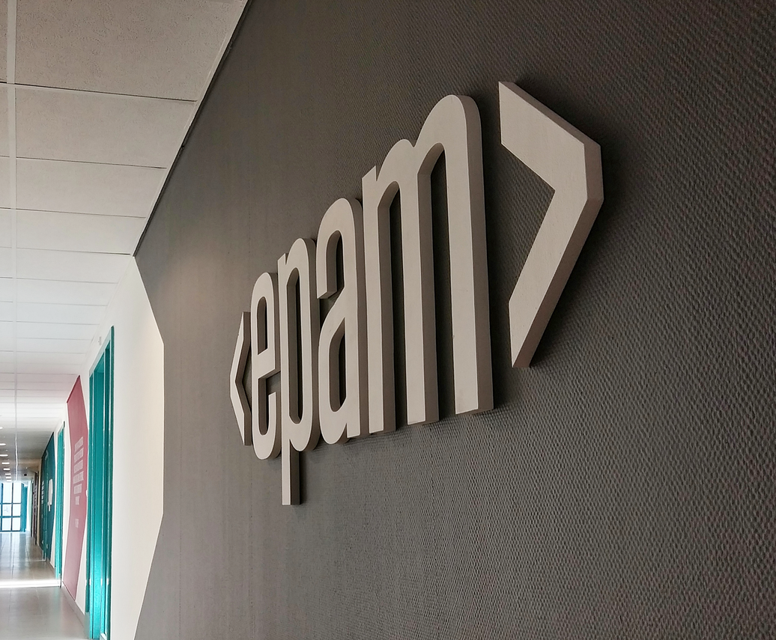

**Company Core Values:-**

EPAM Systems has a set of core values that guide its employees in their work and interactions with clients and each other. These core values reflect the company's commitment to excellence, innovation, and ethical business practices. The core values of EPAM Systems are:

Continuous Learning:

EPAM Systems encourages its employees to pursue continuous learning and professional development. The company provides opportunities for employees to attend training programs, conferences, and other educational events to enhance their skills and knowledge. The company also promotes a culture of knowledge sharing and collaboration to foster ongoing learning.

Respect:

EPAM Systems values respect for its employees, clients, and partners. The company strives to create an inclusive work environment where all employees feel valued and appreciated. EPAM Systems also prioritizes building respectful relationships with clients and partners based on trust, transparency, and mutual respect.

Integrity:

EPAM Systems operates with integrity and ethical business practices. The company upholds high standards of honesty, transparency, and accountability in all of its dealings with clients, employees, and partners. EPAM Systems also maintains strict confidentiality and data security practices to protect client information.

Agility:

EPAM Systems values agility in responding to client needs and market changes. The company is flexible and adaptable, and is committed to delivering high-quality solutions quickly and efficiently. EPAM Systems also embraces change and innovation, and encourages its employees to think creatively and experiment with new ideas.

Collaboration:

EPAM Systems values collaboration and teamwork. The company fosters a culture of openness and communication, and encourages its employees to work together to solve problems and achieve shared goals. EPAM Systems also collaborates closely with clients and partners to develop customized solutions that meet their specific needs.

Excellence:

EPAM Systems is committed to delivering excellence in everything it does. The company upholds high standards of quality, reliability, and performance, and is dedicated to continuous improvement. EPAM Systems also strives to exceed client expectations and to deliver solutions that drive business growth and innovation.

Overall, EPAM Systems' core values reflect the company's commitment to excellence, innovation, and ethical business practices. These values guide the company's employees in their daily work and interactions with clients and each other, and help to create a culture of respect, collaboration, and excellence.

**Origin and Growth of Company :**

EPAM Systems is a global provider of software engineering and IT consulting services. The company was founded in 1993 by Arkadiy Dobkin and Leo Lozner in Minsk, Belarus. EPAM Systems started as a small software development company with just four employees, but has since grown to become one of the largest and most respected software engineering firms in the world.

Origin:

Arkadiy Dobkin, the founder of EPAM Systems, was born in Belarus and studied computer science at the Minsk Institute of Radio Technology. After graduation, Dobkin worked as a software engineer in the Soviet Union's defense industry, where he gained experience working on large-scale software projects. However, Dobkin was interested in pursuing his own entrepreneurial ventures and saw an opportunity to start a software development company in Belarus.

In 1991, Dobkin moved to the United States to pursue an MBA degree at Columbia University in New York. While at Columbia, Dobkin met Leo Lozner, a fellow Belarusian and computer science graduate. Dobkin and Lozner shared a vision for starting a software development company in Belarus that could compete on a global scale.

In 1993, Dobkin and Lozner founded EPAM Systems in Minsk, Belarus. The company initially focused on providing software development services to clients in the United States and Europe, leveraging Belarus' highly skilled and educated workforce to offer high-quality, cost-effective solutions.

Growth:

EPAM Systems began its journey with just four employees, but quickly grew as the company started to gain traction in the global software development market. In the late 1990s, the company established its first office in the United States, in Princeton, New Jersey. This move allowed EPAM Systems to better serve its clients in North America and to expand its reach in the US market.

Throughout the 2000s, EPAM Systems continued to grow rapidly, expanding its global footprint and diversifying its service offerings. The company opened offices in India, China, Hungary, Russia, and other countries, as it sought to tap into local talent and expertise. EPAM Systems also expanded its service offerings to include not just software development, but also testing, maintenance, and other IT consulting services.

In 2004, EPAM Systems became a public company, listing on the New York Stock Exchange (NYSE) under the ticker symbol EPAM. The company's IPO was a major milestone, demonstrating its commitment to transparency and accountability, and providing a platform for future growth and investment.

EPAM Systems continued to build its reputation as a leader in software engineering and IT consulting, winning numerous awards and accolades for its work. In 2019, the company was ranked #6 on Forbes' list of America's Best Employers for Diversity, and #22 on Forbes' list of America's Best Midsize Employers.

Today, EPAM Systems has a presence in over 35 countries around the world and employs more than 47,000 people. The company serves clients in a wide range of industries, including financial services, healthcare, technology, travel, and more. EPAM Systems' success can be attributed to its commitment to excellence, innovation, and customer-centricity, as well as its focus on attracting and retaining top talent from around the world.  
  
EPAM Systems has experienced tremendous growth since its inception in 1993, and the company continues to pursue a growth strategy that is focused on expanding its client base, entering new markets, and investing in new technologies and capabilities.

One of the key pillars of EPAM's growth strategy is its focus on building long-term relationships with its clients. The company has a proven track record of delivering high-quality solutions to its clients and has built a strong reputation for its technical expertise, innovation, and customer-centric approach. By focusing on building long-term relationships with its clients, EPAM is able to generate recurring revenue and increase its share of the clients' IT budgets over time.

Another key element of EPAM's growth strategy is its focus on geographic expansion. The company has a strong presence in North America, Europe, and Asia, but it is also actively pursuing opportunities in other regions, including Latin America and the Middle East. By expanding its geographic footprint, EPAM is able to tap into new markets and access new clients, thereby increasing its revenue and diversifying its client base.

EPAM is also investing in new technologies and capabilities to drive growth. The company has a strong focus on digital transformation and is investing heavily in areas such as artificial intelligence, machine learning, and blockchain. By developing expertise in these emerging technologies, EPAM is able to offer its clients cutting-edge solutions that help them stay ahead of the competition.

In addition to organic growth, EPAM is also pursuing growth through strategic acquisitions. The company has a track record of successful acquisitions, including the acquisition of Dextrys in 2015, which helped EPAM expand its presence in China, and the acquisition of Continuum in 2019, which added capabilities in design and innovation consulting. By acquiring complementary businesses, EPAM is able to accelerate its growth and gain access to new clients and markets.

Overall, EPAM Systems' growth strategy is focused on building long-term relationships with its clients, expanding its geographic footprint, investing in new technologies and capabilities, and pursuing strategic acquisitions. By executing on this strategy, EPAM is well-positioned to continue its strong growth trajectory and deliver value to its clients and shareholders in the years ahead.

**Various departments and their functions:**

EPAM Systems is a leading global provider of digital platform engineering and software development services. The company has more than 41,000 employees worldwide and operates in over 35 countries. EPAM serves clients in various industries, including healthcare, financial services, technology, media and entertainment, and retail. EPAM has a diverse range of departments and functions, each contributing to the company's success. In this article, we will discuss some of the key departments and functions within EPAM.

1. Delivery Management: The delivery management department is responsible for overseeing project delivery, ensuring that projects are delivered on time, within budget, and to the client's satisfaction. The department is responsible for project planning, resource allocation, risk management, and quality control.

2. Engineering: The engineering department is responsible for designing and developing digital platforms and software solutions. The department includes software engineers, architects, and designers who use the latest technologies and tools to develop cutting-edge solutions.

3. Quality Assurance: The quality assurance department is responsible for ensuring that EPAM's products and services meet the highest quality standards. The department is responsible for testing software, identifying and reporting defects, and providing feedback to the engineering department to improve the quality of EPAM's products.

4. Business Analysis: The business analysis department is responsible for analyzing clients' business needs and translating them into technical requirements. The department works closely with clients to understand their business processes, identify pain points, and recommend solutions that improve efficiency and productivity.

5. Sales: The sales department is responsible for identifying new business opportunities, developing relationships with potential clients, and closing deals. The department includes sales representatives, account managers, and business development managers who work closely with clients to understand their needs and propose solutions that meet their requirements.

6. Marketing: The marketing department is responsible for promoting EPAM's products and services to potential clients. The department includes digital marketers, content creators, and event planners who use various channels, such as social media, email marketing, and events, to raise awareness of EPAM's offerings.

7. Human Resources: The human resources department is responsible for recruiting, training, and retaining EPAM's employees. The department is responsible for creating a positive work environment, developing employee skills, and providing competitive compensation and benefits packages.

8. Finance: The finance department is responsible for managing EPAM's financial resources, including budgeting, forecasting, and financial reporting. The department is responsible for ensuring that EPAM's financial performance is healthy and sustainable.

9. Legal: The legal department is responsible for ensuring that EPAM's operations comply with legal and regulatory requirements. The department includes lawyers and legal specialists who provide advice and support on legal matters, such as contracts, intellectual property, and data protection.

10. Operations: The operations department is responsible for managing EPAM's infrastructure and facilities. The department includes IT specialists, facilities managers, and logistics coordinators who ensure that EPAM's operations run smoothly and efficiently.

11. Innovation: The innovation department is responsible for exploring new technologies and trends and identifying opportunities to apply them to EPAM's products and services. The department includes researchers, designers, and strategists who work on developing new ideas and approaches that can help EPAM stay ahead of the competition and offer cutting-edge solutions to its clients.

12. Global Business Units: EPAM has several global business units (GBUs) that specialize in different industries and domains. The GBUs include healthcare, financial services, travel and hospitality, retail and distribution, media and entertainment, and software and high-tech. Each GBU has a team of experts who understand the specific challenges and opportunities in their respective industries and provide customized solutions to clients.

13. Talent Development: The talent development department is responsible for developing EPAM's employees' skills and capabilities. The department includes trainers, coaches, and mentors who provide training programs, certifications, and career development opportunities to help employees grow and advance their careers within the company.

14. Customer Experience: The customer experience department is responsible for ensuring that EPAM's clients have a positive experience working with the company. The department includes customer success managers, customer support specialists, and account managers who work closely with clients to understand their needs and provide solutions that meet their requirements.

15. Cybersecurity: The cybersecurity department is responsible for ensuring that EPAM's products and services are secure and protected from cyber threats. The department includes cybersecurity experts who identify and mitigate potential vulnerabilities, provide security assessments and audits, and develop cybersecurity strategies and policies.

16. Cloud and Infrastructure: The cloud and infrastructure department is responsible for managing EPAM's cloud-based infrastructure and ensuring that it is scalable, reliable, and secure. The department includes cloud architects, DevOps engineers, and infrastructure specialists who use the latest cloud technologies and tools to provide optimal solutions for EPAM's clients.

17. Data Science and Analytics: The data science and analytics department is responsible for analyzing data and providing insights that help clients make informed decisions. The department includes data scientists, analysts, and engineers who use advanced analytics tools and technologies to extract value from data and provide actionable insights.

18. Product Management: The product management department is responsible for defining and managing EPAM's product portfolio. The department includes product managers, product owners, and product marketing specialists who work closely with clients and the engineering department to develop and launch new products and features that meet market needs.



Report

**BEWAKOOF Shopping Web Application**

Document Details:

|  |  |
| --- | --- |
| Title | Test strategy document for Bewakoof Shopping web application |
| Date | 26-04-2023 |
| File name | Test Strategy Bewakoof Shopping |
| Author | Team Bewakoof shopping |
| Team | Rahul, Anil, Pradeep |

**TABLE OF CONTENT**

1. Scope 5
2. Application Overview 5
3. Test Approach 6
4. Test Types 6
5. Roles and Responsibilities 7
6. Environment Requirements 8
7. Testing Tools 8
8. Industry Standards to follow 8
9. Test deliverables 10
10. Risk and mitigation 14
11. Reporting tool 14
12. Test summary 14
13. Approvals 14

**1.SCOPE**

The Shopping application is termed as selling and buying behaviour of products and services over the internet. This online shopping system provides a 24×7 service, that is customers can surf the website, place orders anytime they wish to. It is also referred to as the sales of different items on the marketplaces in which money transaction activity takes place.

**Functional Requirements:**

* The main page consists of Logo of Application, Login/signup page, offers page, product page, profile page and helpline details under the bottom of Home page.
* The page consists of options such as product size, color, and type. There is a sorting feature to filter out products. There is also the “Add to Cart” or “Go to cart” feature present in the category pages**.**
* The page Consists of the product title, description, product images, related products, Add to Cart feature, Product comparison, additional product information.
* The Page consist of list view, removing the product from the list, cash on delivery option, Select delivery option, card payment, pay now option.

**Non Functional Requirements:**

Capturing the behavior when a large number of people are using the software at the same time. Most of the time it is experienced that the servers are busy or unavailable due to heavy load.

* Validates that the system meets the expected response time. Evaluates that the significant elements of the application meet the desired response time.
* Whether the Application easy to use.

**2.OVERVIEW**  
Online Shopping is a lifestyle e-commerce web application, which retails various fashion and lifestyle products (Currently Men’s and Women’s wear). This project allows viewing various products available enables registered users to purchase desired products instantly using Card payment, Net banking and UPI processor (Instant Pay) and also can place order by using Cash on Delivery (Pay Later) option. This project provides an easy access to Administrators and Managers to view orders placed using Pay Later and Instant Pay options. The main purpose of this Shopping application is where product like clothes can be bought from the comfort of home through the Internet.

**www.bewakoof.com**



**3.TEST APPROACH**

* Test levels
* Test types
* Roles and responsibilities
* Environment requirements ( hardware and software requirements).

**4.TEST LEVELS**

During the testing process the testers tested application in various levels. Such as, Unit testing, Integration testing, system testing and user acceptance testing.

**Test Types:**

* **FUNCTIONAL TESTING:**

A Test is a set of preconditions, procedures (inputs or actions), and expected results used to determine whether a system works correctly. Test cases should have the following structure: a brief statement of purpose, description of precondition, actual test case inputs, expected outputs, description of expected postconditions, and execution history (date/person in charge/product version/pass or fail result).

* **USABILITY TESTING :**

Usability testing is defined as the evaluation of a product by testing it on potential users. To test how users will add multiple items in the cart. Is it easy for them to set the prices in their desired currency? Can they choose their preferred payment method without any hassle? if users can pick the payment methods they want, you can evaluate whether the website shows payment methods valid for the user’s country.

* **INTERFACE TESTING :**

ensure that end-users or customer should not encounter any problem when using Application. to check its user-friendliness as well. To verify security requirements while communication propagates between the systems and check if a solution is capable to handle network failures between an application server and website.

* **COMPACTIBILITY TESTING :**

It helps avoid issues related to versions updates, navigation flows, screen size adaptation, broken tables or frames, etc.  and the testing will done in

* Testing on PC, on different browsers like Safari, Chrome, Firefox, IE.
* Testing on different mobile devices that have different platforms like iOS, Android or Windows.
* Testing on networks like 4G, 3G or wifi.
* Testing on multiple operating systems such as Mac, Windows, Linux.
* **PERFORMANCE TESTING :**

Performance Testing is that type of software testing that pinpoints on how a system running the system performs under a particular circumstance. Performance testing measures depending on the benchmarks and standards. Performance testing helps the developers to eliminate the bottlenecks. Performance of a mobile or a web application is basically its capability of performing all the functions which it is supposed to do flawlessly without causing any delay or complication. its primary work, such as loading pages, showing the products, bringing out proper search results for the viewers, and loading the pages on time as well.

**5.ROLES AND RESPONSIBILITIES**

* Creating, enhancing, debugging, and running the test cases.
* Collating and monitoring the defect management process.
* Managing the changes and executing regression tests.
* Coming up with exact solutions for problems related to object identity and error handling.
* Interacting with customers/clients to solve the various issues they face and updating on the situation.
* Automating the design of a framework.
* Implementing it as per the structure of the project.
* Creating an automation test plan and getting approval.
* Identifying and selecting the automation test cases.
* Applying various designs and documenting the automation test strategy.
* Configuring Selenium Test Environment (STE) in order to set it up.
* Participating in Selenium Environment Setup with an Integrated Development Environment (IDE).

**6. ENVIRONMENT REQUIREMENTS**

**Software Environment:**

* Operating System- windows
* Java development toolkit.

**Hardware Environment:**

* Processor: Dual core
* RAM: 2GB
* Hard disk: 512GB.

**7.TESTING TOOLS**

Software Requirements:

* Selenium Testing tool.
* Jenkins

Hardware Requirements:

* Ram -2gb.
* Operation system- windows, android.

**8.INDUSTRY STANDARDS USED**

* [**IEEE 1008-1987 - IEEE Standard for Software Unit Testing**](https://standards.ieee.org/standard/1008-1987.html)

An integrated approach to systematic and documented unit testing is defined. It uses unit design and unit implementation information, in addition to unit requirements, to determine the completeness of the testing. The testing process described composed of a hierarchy of phases, activities, and tasks and defines a minimum set of tasks for each activity. The standard can be applied to the unit testing of any digital computer software or firmware and to the testing of both newly developed and modified units.

* [**IEEE/ISO/IEC 29119-2-2013 - ISO/IEC/IEEE International Standard - Software and systems engineering —Software testing —Test processes**](https://standards.ieee.org/standard/29119-2-2013.html)

The purpose of the ISO/IEC/IEEE 29119 series of software testing standards is to define an internationally-agreed set of standards for software testing that can be used by any organization when performing any form of software testing. ISO/IEC/IEEE 29119-2 comprises test process descriptions that define the software testing processes at the organizational level, test management level and dynamic test levels. It supports dynamic testing, functional and non-functional testing, manual and automated testing, and scripted and unscripted testing. The processes defined in ISO/IEC/IEEE 29119-2 can be used in conjunction with any software development lifecycle model. Since testing is a key approach to risk-mitigation in software development, ISO/IEC/IEEE 29119-2 follows a risk-based approach to testing. Risk-based testing is a common industry approach to strategizing and managing testing. Risk-based testing allows testing to be prioritized and focused on the most important features and functions.

* [**IEEE/ISO/IEC 29119-3-2013 - ISO/IEC/IEEE International Standard - Software and systems engineering — Software testing —Test documentation**](https://standards.ieee.org/standard/29119-3-2013.html)

The purpose of the ISO/IEC/IEEE 29119 series of software testing standards is to define an internationally-agreed set of standards for software testing that can be used by any organization when performing any form of software testing. ISO/IEC/IEEE 29119-3 includes templates and examples of test documentation. The templates are arranged within clauses reflecting the overall test process description structure in ISO/IEC/IEEE 29119-2, i.e. by the test process in which they are being produced. Annex A contains outlines of the contents of each document. Annex B contains mappings ISO/IEC/IEEE 29119-2. Annex C contains an overview of the examples. Annexes D to S contain examples of the application of the templates. Annex T provides mappings to existing standards. The Bibliography for this part of ISO/IEC/IEEE 29119 is at the end of the document. ISO/IEC/IEEE 29119-3 supports dynamic testing, functional and non-functional testing, manual and automated testing, and scripted and unscripted testing.

**9.TEST DELIVERABLES**

* Test Scenario
* Test cases and data
* Requirement traceability matrix.
* Test summary report
* Test closure report

**9.1 Test Scenarios For shopping Web application:**

|  |  |  |
| --- | --- | --- |
| **SN** | **Test scenario ID** | **Test Objective/Test scenarios** |
| 1 | AddNewUserTest | Validating the "Personal Details" feature as a new user. |
| 2 | AddToWishlist | Validate already existing users username and password |
| 3 | ExistingUser | Validate already existing users username and password |
| 4 | PaymentMethod | Selecting the Payment option for buying the product |
| 5 | Productfeild | Checking the product page,that user can select the desired attribute of the product. |
| 6 | SearchFeild | Searching for the product by their names |
| 7 | PriceSorting | Check the product availability,product price and price sorting |

**9.2 Test cases Data:**

**1. AddNewUserTest:-**

|  |  |
| --- | --- |
|  |  |
| Addnewuserr.png |  |

**2.Addtowishlist:**

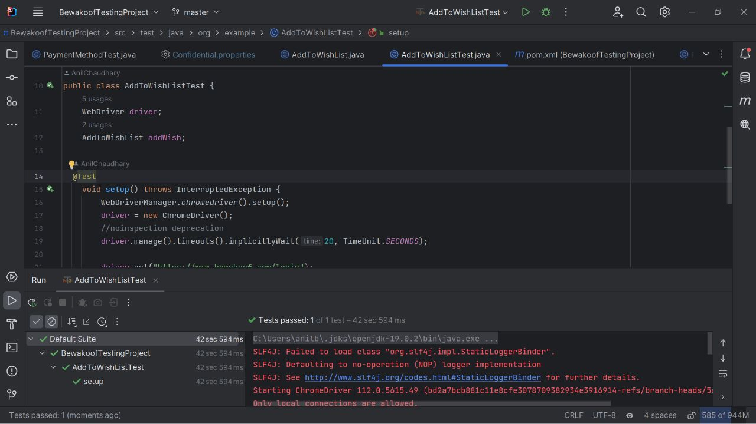

**3.ExistingUserTest**

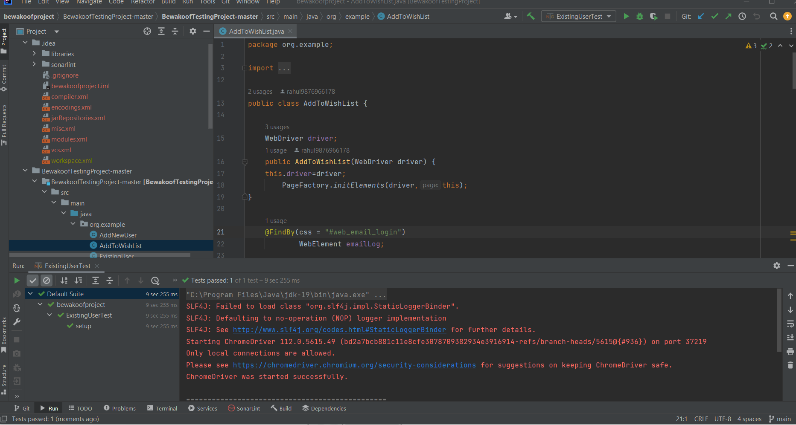

**4.PaymentMethod**

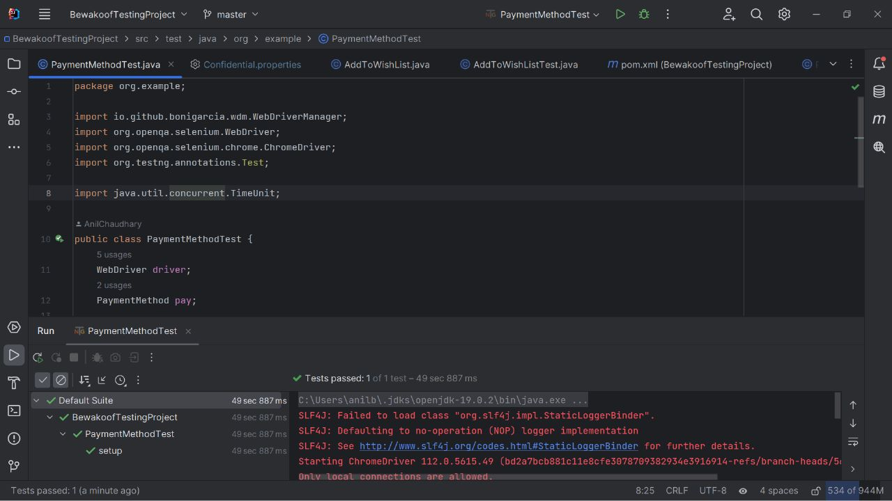

**5.PriceSorting:-**

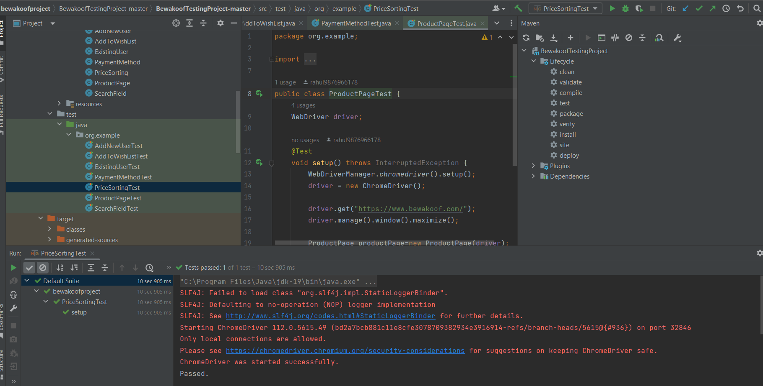

**6.ProductPage:**

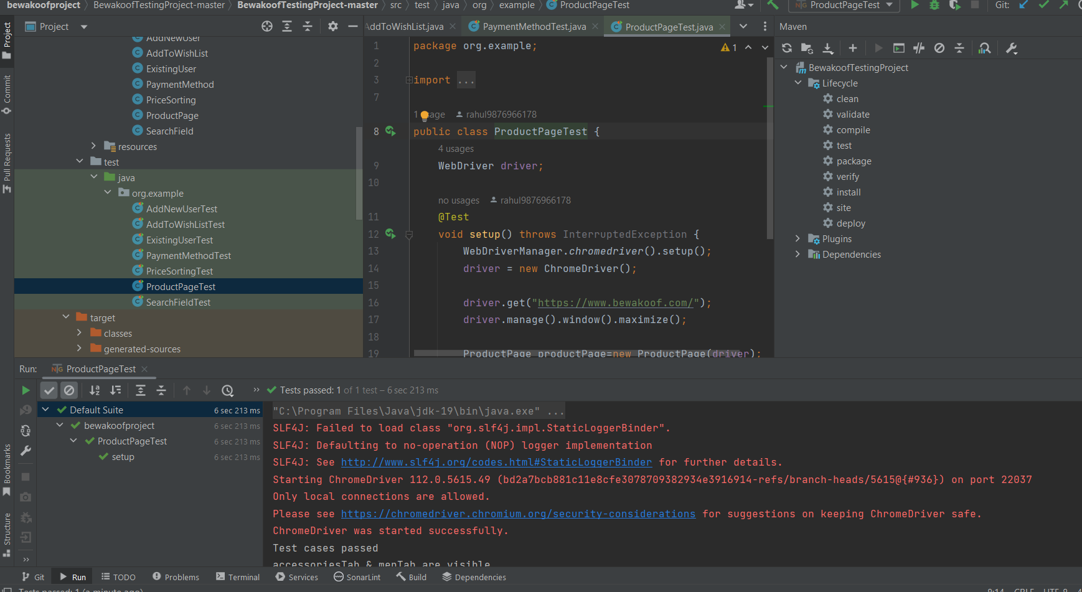

**7.Searchfieldtest:**

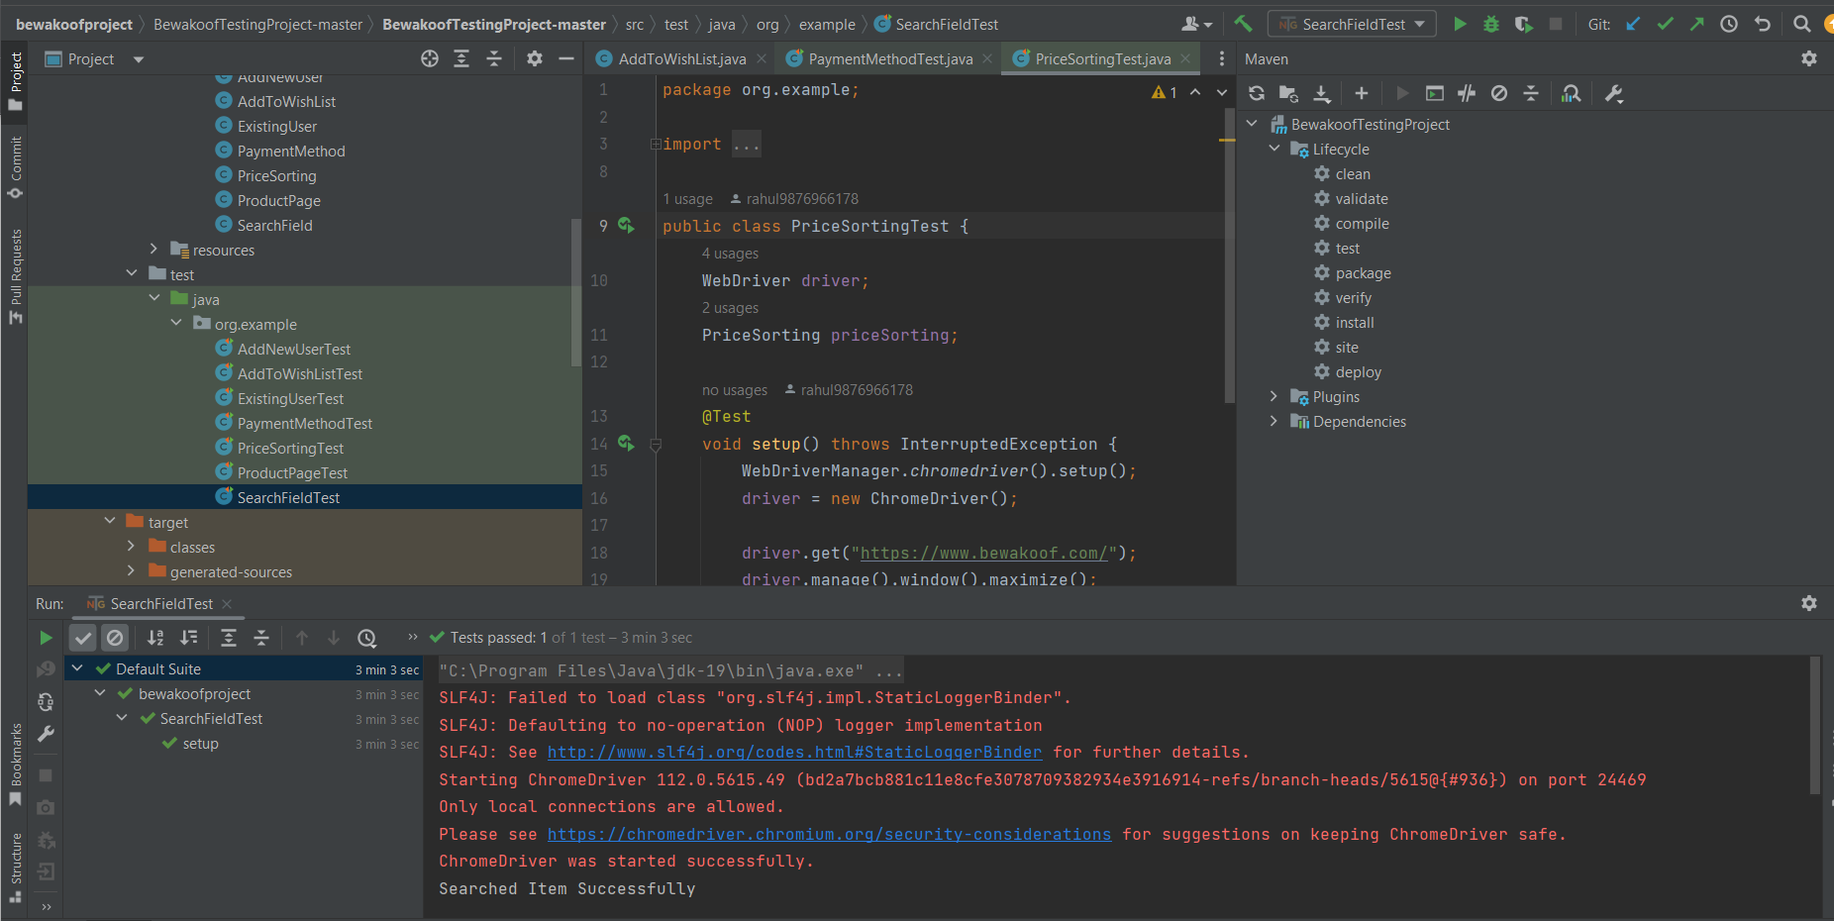

**10.RISK AND MITIGATION**

* Broken Access control
* Payment security
* Use secure passwords.

**11.REPORTING TOOL**

JENKINS is the reporting tool for the Project.

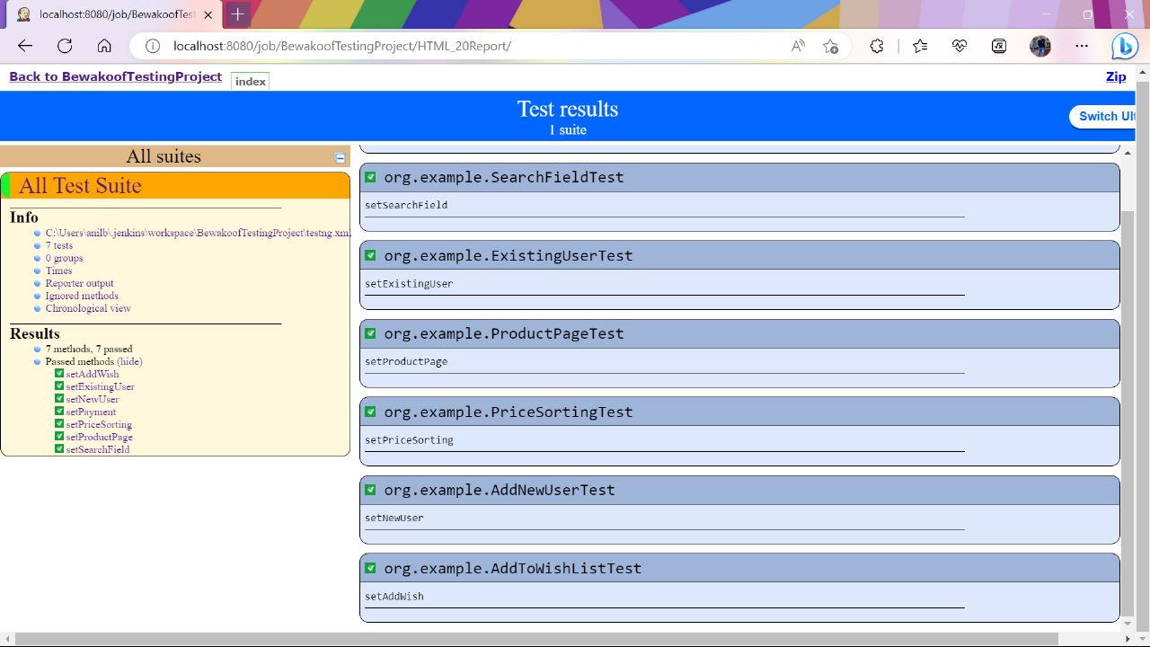

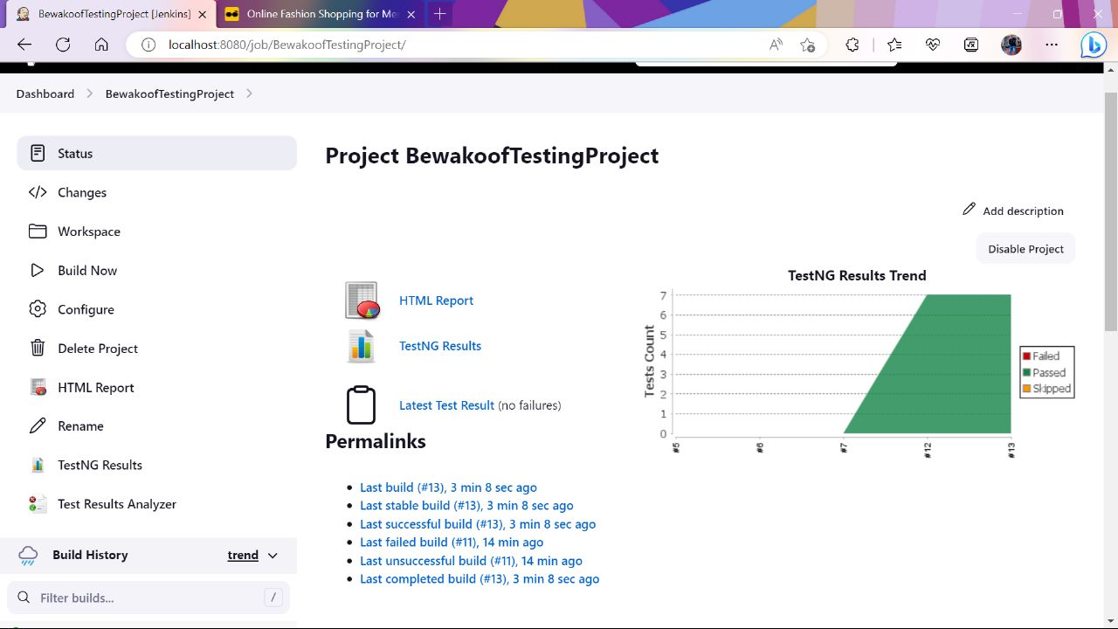

**12.TEST SUMMARY**

A Test Strategy document is created for shopping web application as per the content. It needs to be reviewing for sign-off by all entities involved in project management, business team, development team, and system administration Team.

